**CS3021 Tutorial 1**

**Q2:** Stack of 4 frames deep

|  |
| --- |
| b = 21 |
| a = 14 |
| Return address |
| Saved ebp |
| b = 14 |
| a = 21 |
| Return address |
| Saved ebp |
| b = 7 |
| a = 14 |
| Return address |
| Saved ebp |
| b = 0 |
| a = 7 |
| Return address |
| Saved ebp |

**Q3:** This is a statement that my program builds, runs and satisfies all tests. See the relevant screen shots. The files have also been included in the submission.

***t1.h:***

extern "C" int g; // external global variable g

extern "C" int _cdecl min(int, int, int);

extern "C" int _cdecl gcd(int, int);

extern "C" int _cdecl p(int, int, int, int);

***t1.asm:***

.686

.model flat, C

option casemap:none

.data

public g

g DWORD 4

.code

public min

min: push ebp

mov ebp, esp

sub esp, 4

mov eax, [ebp+8]

mov [ebp-4], eax

mov eax, [ebp+12]

cmp eax, [ebp-4]

jge greater1

mov [ebp-4], eax

greater1:

mov eax, [ebp+16]

cmp eax, [ebp-4]

jge greater2

mov [ebp-4], eax

greater2:

mov eax, [ebp-4]

mov esp, ebp

pop ebp

ret 0

public p

p: push ebp

mov ebp, esp

push [ebp+12]

push [ebp+8]

push g

call min

add esp, 12

push [ebp+20]

push [ebp+16]

push eax

call min

add esp, 12

mov esp, ebp

pop ebp

ret 0

public gcd

gcd: push ebp

mov ebp, esp

mov ecx, [ebp+12]

cmp ecx, 0

je setResult

mov ecx, [ebp+12]

mov eax, [ebp+8]

cdq

idiv ecx

mov ecx, [ebp+12]

push edx

push ecx

call gcd

add esp, 8

jmp returnFunc

setResult:

mov eax, [ebp+8]

returnFunc:

mov esp, ebp

pop ebp

ret 0

end

**Build Screenshot:**

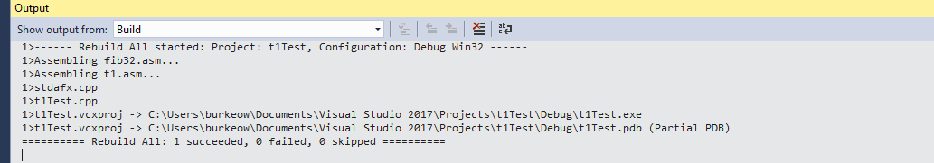

**Console Screenshot:**

